# Applecross Senior High School

### Semester One Examination, 2020

### Question/Answer booklet

# MATHEMATICS

**SOLUTIONS**

**METHODS**

**UNIT 1**

## Section Two:

## Calculator-assumed

|  |  |  |  |  |  |  |  |  |  |  |
| --- | --- | --- | --- | --- | --- | --- | --- | --- | --- | --- |
| WA student number: In figures |  |  |  |  |  |  |  |  |  |  |

In words

Your name

|  |  |
| --- | --- |
| Number of additional answer booklets used (if applicable): |  |

## Time allowed for this section

Reading time before commencing work: ten minutes

Working time: one hundred minutes

## Materials required/recommended for this section

***To be provided by the supervisor***

This Question/Answer booklet

Formula sheet (retained from Section One)

***To be provided by the candidate***

Standard items: pens (blue/black preferred), pencils (including coloured), sharpener,  
correction fluid/tape, eraser, ruler, highlighters

Special items: drawing instruments, templates, notes on two unfolded sheets of A4 paper, and up to three calculators approved for use in this examination

## Important note to candidates

No other items may be taken into the examination room. It is **your** responsibility to ensure that you do not have any unauthorised material. If you have any unauthorised material with you, hand it to the supervisor **before** reading any further.

## Structure of this paper

|  |  |  |  |  |  |
| --- | --- | --- | --- | --- | --- |
| Section | Number of questions available | Number of questions to be answered | Working time (minutes) | Marks available | Percentage of examination |
| Section One: Calculator-free | 8 | 8 | 50 | 52 | 35 |
| Section Two: Calculator-assumed | 13 | 13 | 100 | 98 | 65 |
|  | | |  | **Total** | 100 |

## Instructions to candidates

1. The rules for the conduct of examinations are detailed in the school handbook. Sitting this examination implies that you agree to abide by these rules.

2. Write your answers in this Question/Answer booklet preferably using a blue/black pen.  
Do not use erasable or gel pens.

3. You must be careful to confine your answers to the specific question asked and to follow any instructions that are specific to a particular question.

4. Show all your working clearly. Your working should be in sufficient detail to allow your answers to be checked readily and for marks to be awarded for reasoning. Incorrect answers given without supporting reasoning cannot be allocated any marks. For any question or part question worth more than two marks, valid working or justification is required to receive full marks. If you repeat any question, ensure that you cancel the answer you do not wish to have marked.

5. It is recommended that you do not use pencil, except in diagrams.

6. Supplementary pages for planning/continuing your answers to questions are provided at the end of this Question/Answer booklet. If you use these pages to continue an answer, indicate at the original answer where the answer is continued, i.e. give the page number.

7. The Formula sheet is not to be handed in with your Question/Answer booklet.

Section Two: Calculator-assumed 65% (98 Marks)

This section has**thirteen** questions. Answer **all** questions. Write your answers in the spaces provided.

Working time: 100 minutes.

Question 9 (5 marks)

Shape below consists of sector of circle centre joined to sector of a different circle, also centre . is a straight line of length cm, arc is cm long and radians.

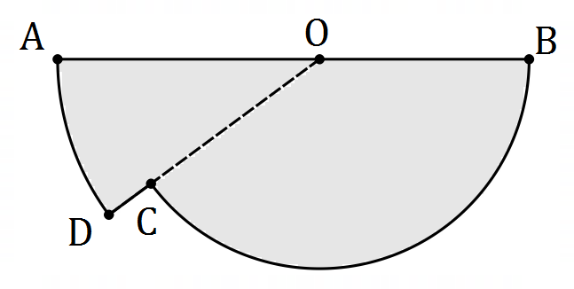

(a) Determine the length . (2 marks)

|  |
| --- |
| **Solution** |
| Let so that |
| **Specific behaviours** |
| ✓ correct use of arc length  ✓ correct length |

(b) Determine the area of the shape. (3 marks)

|  |
| --- |
| **Solution** |
| Let |
| **Specific behaviours** |
| ✓ area of sector  ✓ radius and angle of sector  ✓ area of shape |

Question 10 (8 marks)

The height metres of a particle above level ground is defined as a function of time seconds as follows:

(a) Determine the height of the particle when

(i) . (1 mark)

|  |
| --- |
| **Solution** |
|  |
| **Specific behaviours** |
| ✓ (i) correct  ✓ (ii) correct |

(ii) . (1 mark)

(b) Determine the maximum height reached by the particle and the time it reached this height.

(2 marks)

|  |
| --- |
| **Solution** |
| From graph of :  Maximum height: when . |
| **Specific behaviours** |
| ✓ correct height  ✓ correct time |

(c) Determine the time(s) that the particle was at a height of m. (2 marks)

|  |
| --- |
| **Solution** |
| From graph of :  when |
| **Specific behaviours** |
| ✓ one time  ✓ both times |

(d) State the range of the function for the given domain. (2 marks)

|  |
| --- |
| **Solution** |
| Range of : |
| **Specific behaviours** |
| ✓ upper limit  ✓ lower limit, correct inequality |

Question 11 (6 marks)

Two events are such that , and .

Determine the probability that

(a) both events occur. (2 marks)

|  |
| --- |
| **Solution** |
|  |
| **Specific behaviours** |
| ✓ indicates use of conditional formula  ✓ correct probability |

(b) at least one event occurs. (2 marks)

|  |
| --- |
| **Solution** |
|  |
| **Specific behaviours** |
| ✓ indicates use of rule  ✓ correct probability |

(c) neither event occurs. (1 mark)

|  |
| --- |
| **Solution** |
|  |
| **Specific behaviours** |
| ✓ correct probability |

(d) occurs given that has occurred. (1 mark)

|  |
| --- |
| **Solution** |
|  |
| **Specific behaviours** |
| ✓ correct probability |

Question 12 (8 marks)

The height above ground level, m, of a seat on a steadily rotating Ferris wheel minutes after the wheel begins to move is given by

(a) Determine the initial height of the seat. (1 mark)

|  |
| --- |
| **Solution** |
|  |
| **Specific behaviours** |
| ✓ correct height |

(b) Graph the height of the seat against time on the axes below. (4 marks)

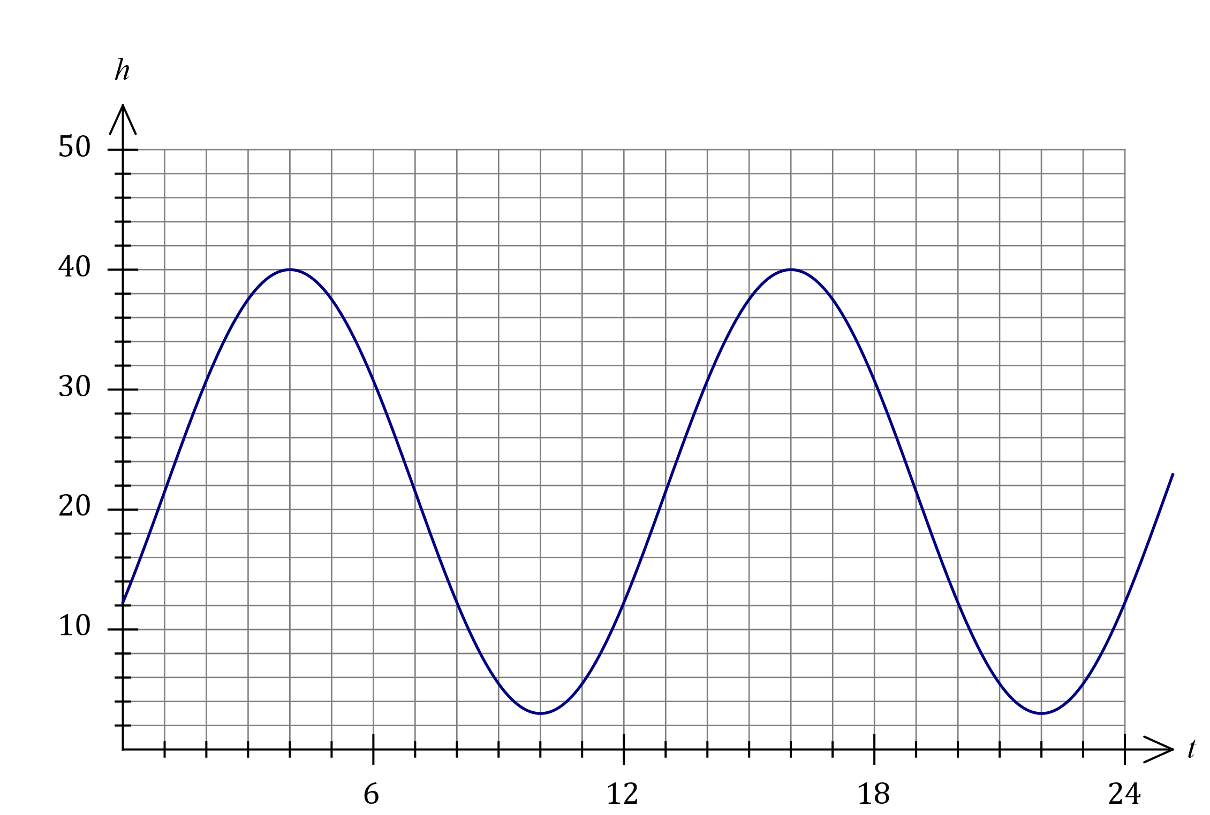

|  |
| --- |
| **Solution** |
| See graph |
| **Specific behaviours** |
| ✓ and  ✓ correct maximums  ✓ correct minimums  ✓ smooth curve |

(c) Determine

(i) the maximum height above ground reached by the seat. (1 mark)

|  |
| --- |
| **Solution** |
|  |
| **Specific behaviours** |
| ✓ correct height |

(ii) the time taken, to the nearest second, for the seat to first reach a height of m above ground level. (2 marks)

|  |
| --- |
| **Solution** |
|  |
| **Specific behaviours** |
| ✓ time as decimal  ✓ time to nearest second |

Question 13 (6 marks)

The graph , where has a turning point at .

(a) State the equation of the line of symmetry for the graph of . (1 mark)

|  |
| --- |
| **Solution** |
|  |
| **Specific behaviours** |
| ✓ correct equation |

(b) Determine the value of the constant and the value of the constant . (3 marks)

|  |
| --- |
| **Solution** |
|  |
| **Specific behaviours** |
| ✓ writes in squared form  ✓ value of  ✓ value of |

(c) The graph of is translated units to the left and units upwards. Determine the equation of the resulting curve. (2 marks)

|  |
| --- |
| **Solution** |
| New turning point at .  Equation is |
| **Specific behaviours** |
| ✓ identifies new turning point  ✓ correct equation (either form) |

Question 14 (6 marks)

When a random sample of people from a university were classified according to whether they had a driver's licence (event ) and whether they wore spectacles (event ), it was observed that , and .

(a) Determine

(i) . (1 mark)

|  |
| --- |
| **Solution** |
|  |
| **Specific behaviours** |
| ✓ correct number |

(ii) . (1 mark)

|  |
| --- |
| **Solution** |
|  |
| **Specific behaviours** |
| ✓ correct number |

(b) Determine the probability that a randomly chosen person from the sample

(i) does not have a driver's licence. (2 marks)

|  |
| --- |
| **Solution** |
|  |
| **Specific behaviours** |
| ✓ numerator  ✓ denominator |

(ii) wears spectacles given that they have a driver's licence. (2 marks)

|  |
| --- |
| **Solution** |
|  |
| **Specific behaviours** |
| ✓ numerator  ✓ denominator |

Question 15 (8 marks)

Consider part of the unit circle shown below, where .

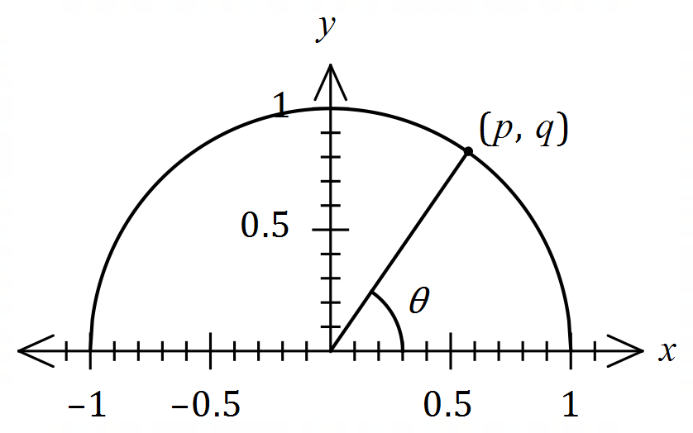

Determine, in terms of and / or , an expression for each of the following:

(a) . (1 mark)

|  |
| --- |
| **Solution** |
|  |
| **Specific behaviours** |
| ✓ correct expression |

(b) . (2 marks)

|  |
| --- |
| **Solution** |
|  |
| **Specific behaviours** |
| ✓ uses reflection  ✓ correct expression |

|  |
| --- |
| **Solution** |
|  |
| **Specific behaviours** |
| ✓ uses fundamental relationship  ✓ correct expression |

(c) . (2 marks)

(d) . (3 marks)

|  |
| --- |
| **Solution** |
|  |
| **Specific behaviours** |
| ✓ halves angle  ✓ uses sum identity  ✓ correct expression |

Question 16 (8 marks)

A polynomial of degree passes through the points with coordinates and .

(a) Determine the equation of the polynomial in expanded form. (4 marks)

|  |
| --- |
| **Solution** |
| Using roots:  Use 4th point:  Expand: |
| **Specific behaviours** |
| ✓ factored form using roots  ✓ substitutes fourth point  ✓ correct value of  ✓ correct expanded form |

(b) Draw the graph of the polynomial on the axes below, indicating the coordinates of all turning points. (4 marks)

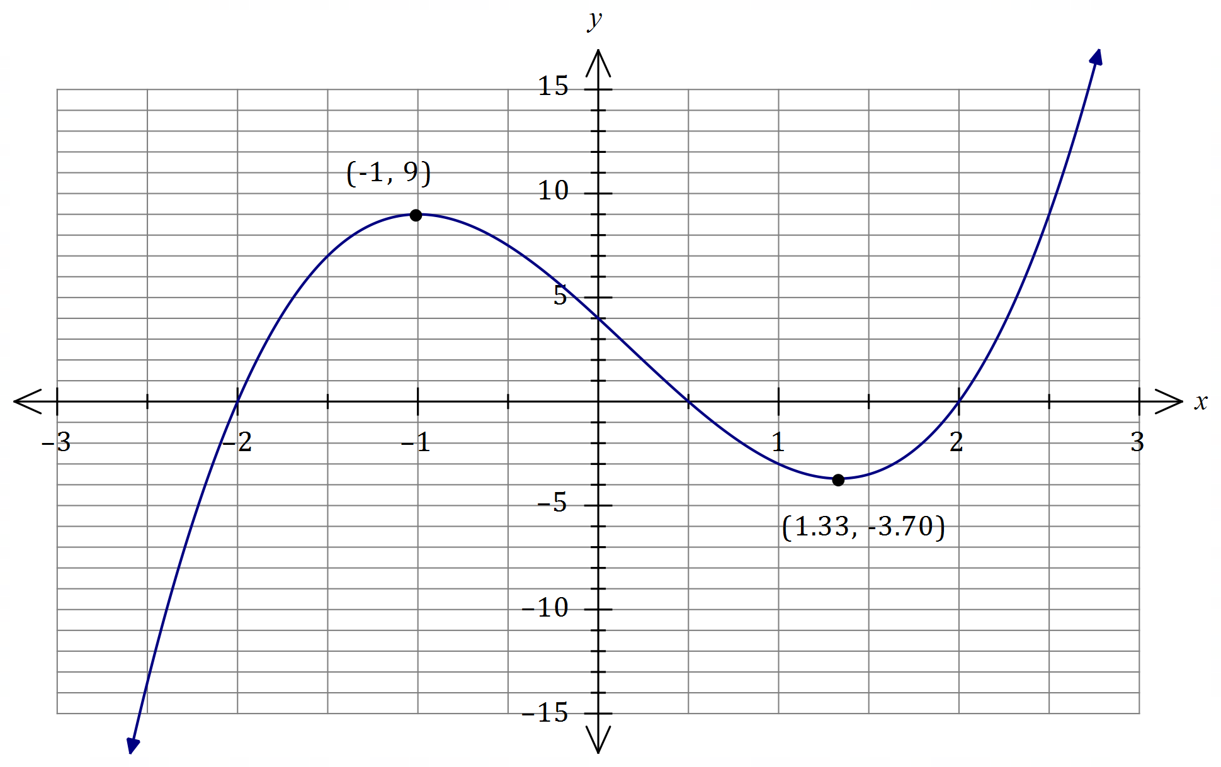

|  |
| --- |
| **Solution** |
| See graph |
| **Specific behaviours** |
| ✓ all roots and -intercept  ✓ labelled maximum  ✓ labelled minimum  ✓ smooth curve |

Question 17 (7 marks)

Let and .

(a) Evaluate . (2 marks)

|  |
| --- |
| **Solution** |
|  |
| **Specific behaviours** |
| ✓ evaluates correctly  ✓ correct value |

(b) State the domain of . (2 marks)

|  |
| --- |
| **Solution** |
|  |
| **Specific behaviours** |
| ✓ correct inequality  ✓ correct bound |

(c) State the range of . (1 mark)

|  |
| --- |
| **Solution** |
|  |
| **Specific behaviours** |
| ✓ correct range (symbols or words) |

(d) Determine the coordinates of the point(s) of intersection of and .

(2 marks)

|  |
| --- |
| **Solution** |
| Using graph/CAS: |
| **Specific behaviours** |
| ✓ -coordinate  ✓ -coordinate |

Question 18 (8 marks)

The graph of is drawn below, where .

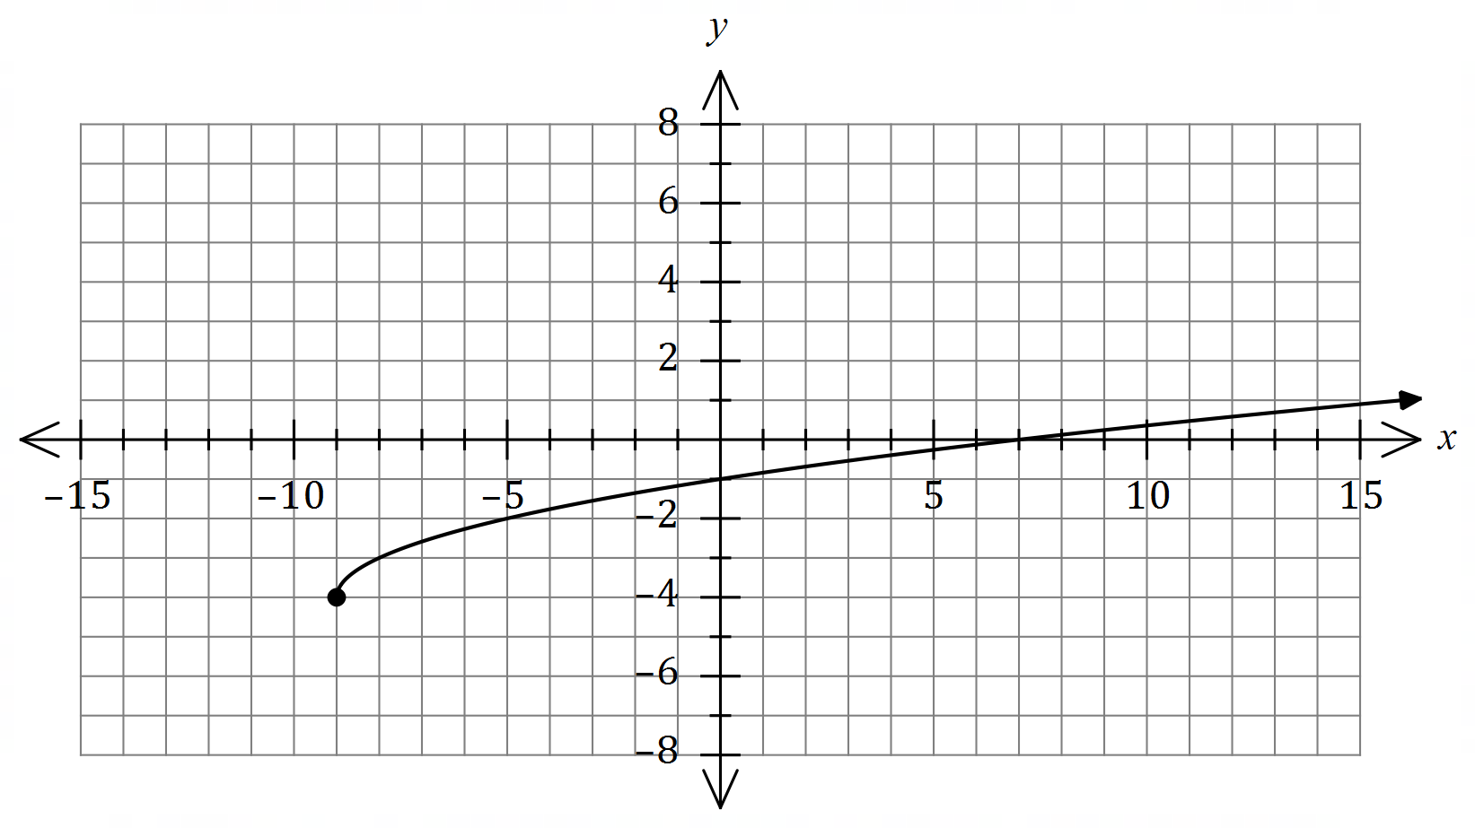

(a) Determine the value of the constant and the value of the constant . (2 marks)

|  |
| --- |
| **Solution** |
|  |
| **Specific behaviours** |
| ✓ value of  ✓ value of |

(b) Draw the graph of on the axes below. (3 marks)

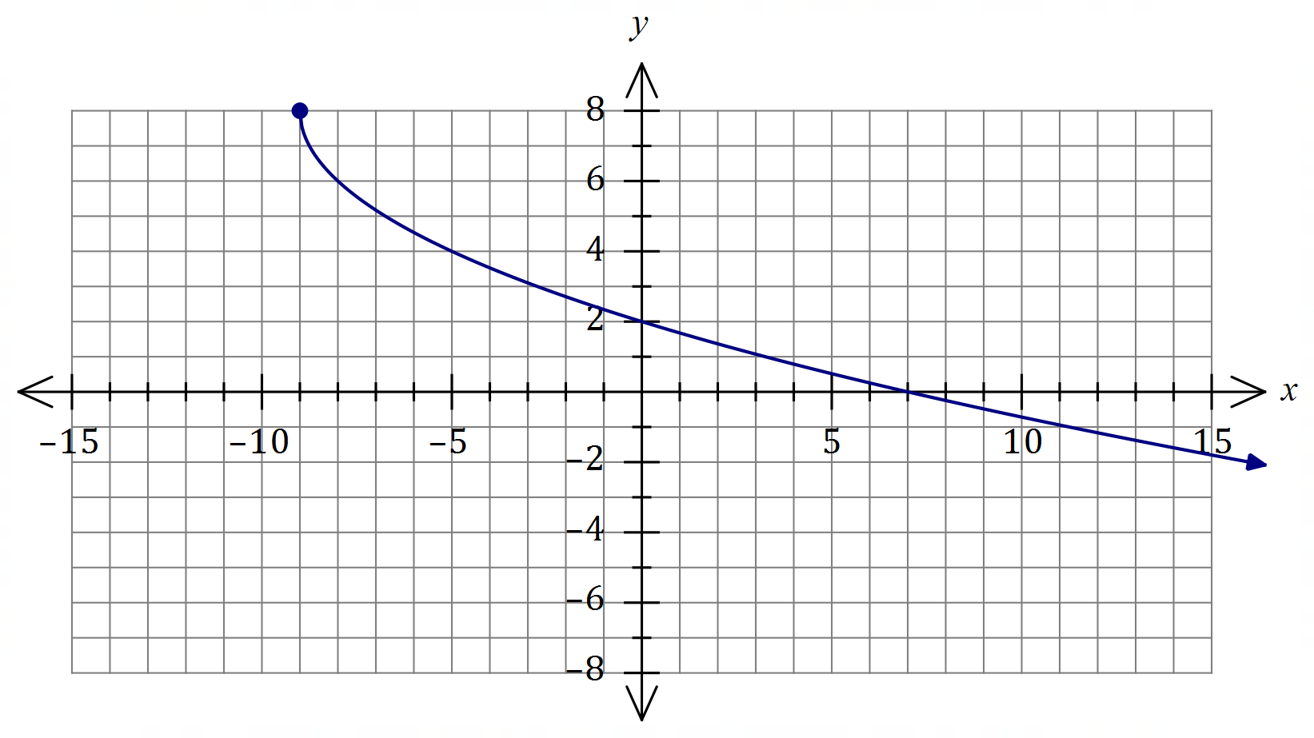

|  |
| --- |
| **Solution** |
| See graph |
| **Specific behaviours** |
| ✓ endpoint at  ✓ thru' and  ✓ smooth curve |

(c) Draw the graph of on the axes below. (3 marks)

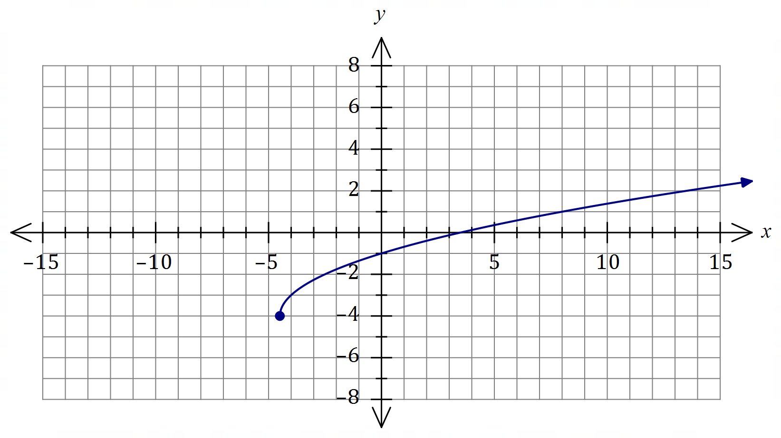

|  |
| --- |
| **Solution** |
| See graph |
| **Specific behaviours** |
| ✓ endpoint at  ✓ thru' and  ✓ smooth curve |

Question 19 (9 marks)

The graph of is shown, where and and are constants.

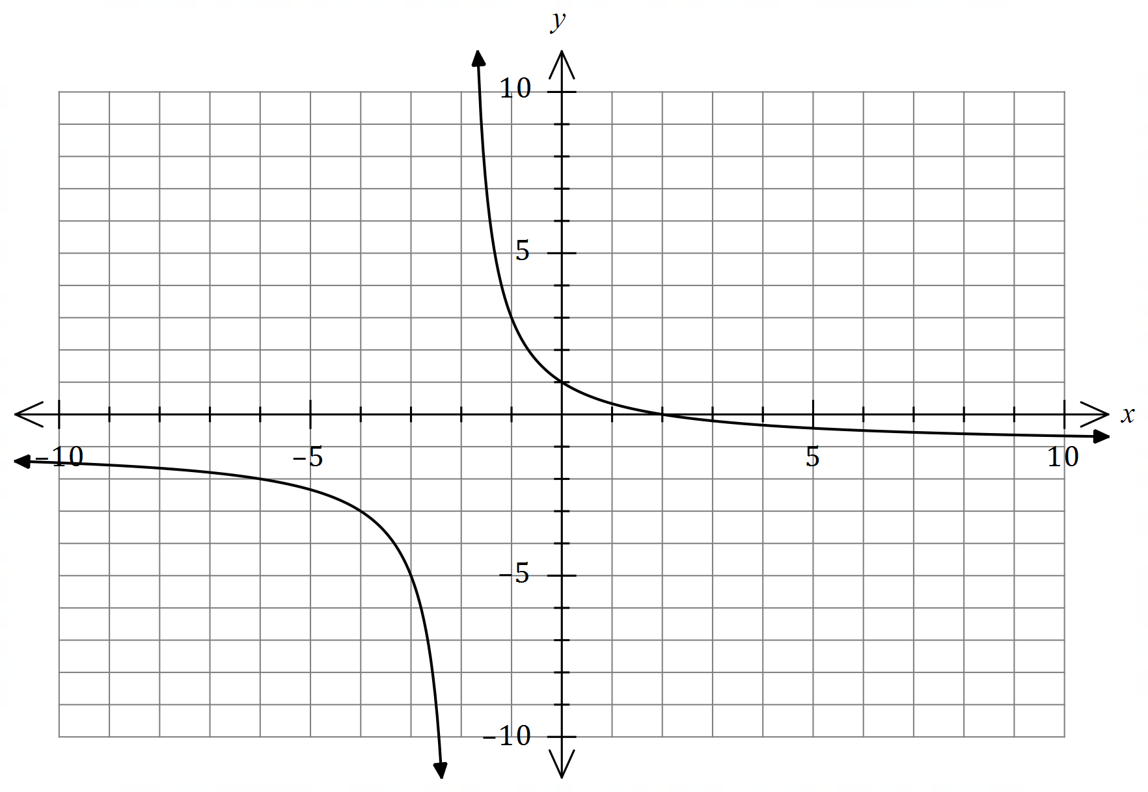

(a) Determine the value of , the value of and the value of . (3 marks)

|  |
| --- |
| **Solution** |
|  |
| **Specific behaviours** |
| ✓ value of  ✓ value of  ✓ value of |

(b) State the domain and range of . (2 marks)

|  |
| --- |
| **Solution** |
| Domain:  Range: |
| **Specific behaviours** |
| ✓ correct domain  ✓ correct range |

(c) On the axes below, draw the graph of and label all asymptotes with their equations. (4 marks)

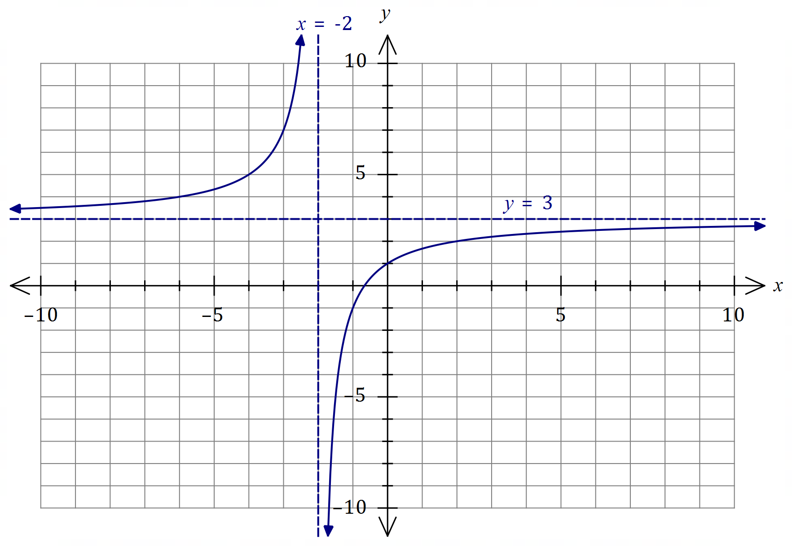

|  |
| --- |
| **Solution** |
| See graph |
| **Specific behaviours** |
| ✓ vertical asymptote with equation  ✓ horizontal asymptote with equation  ✓ -intercept and graph for  ✓ remainder of graph |

Question 20 (11 marks)

(a) Determine the area of triangle when , and cm.

(4 marks)

|  |
| --- |
| **Solution** |
|  |
| **Specific behaviours** |
| ✓ sketch of triangle  ✓ correct use of sine rule  ✓ length of second side  ✓ correct area |

(b) The area of triangle is cm2, and as shown in the diagram. Determine the length of . (4 marks)

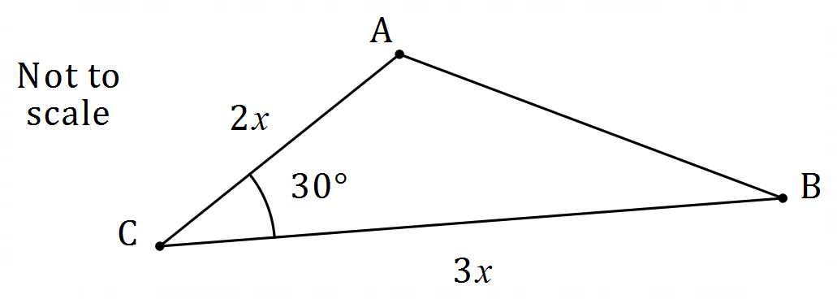

|  |
| --- |
| **Solution** |
|  |
| **Specific behaviours** |
| ✓ area equation  ✓ value of  ✓ cosine rule  ✓ length of |

(c) In triangle , cm, cm and Determine the smallest possible area of the triangle. (3 marks)

|  |
| --- |
| **Solution** |
| For smallest area need to be small as possible: |
| **Specific behaviours** |
| ✓ size of angle  ✓ smallest size of angle  ✓ correct area |

Question 21 (8 marks)

The graph of is drawn below, where and are positive constants.

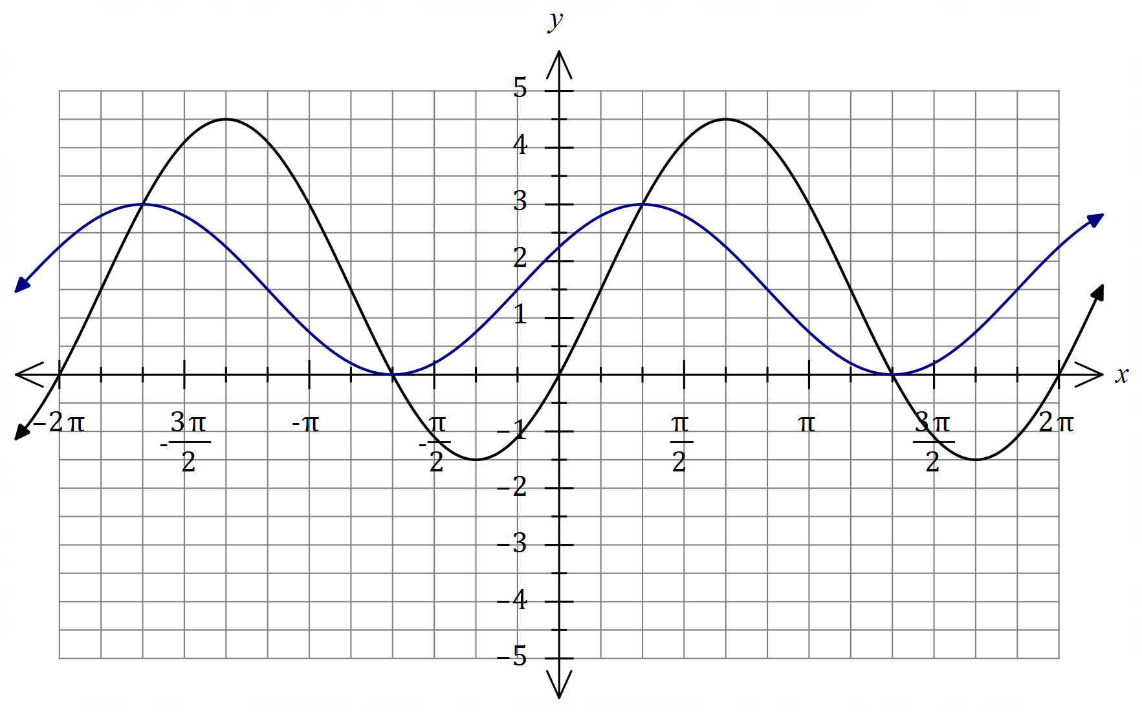

|  |
| --- |
| **Solution (b)** |
| See graph |
| **Specific behaviours** |
| ✓ both maxima  ✓ both minima  ✓ smooth curve |

(a) Determine the value of , the value of and the value of , where . (3 marks)

|  |
| --- |
| **Solution** |
|  |
| **Specific behaviours** |
| ✓ value of  ✓ value of  ✓ value of |

(b) On the same axes, draw the graph of . (3 marks)

(c) Solve for . (2 marks)

|  |
| --- |
| **Solution** |
| Using intersection of graphs: |
| **Specific behaviours** |
| ✓ a correct solution, anywhere  ✓ two solutions as given |

Supplementary page

Question number: _________

© 2020 WA Exam Papers. Applecross Senior High School has a non-exclusive licence to copy and communicate this document for non-commercial, educational use within the school. No other copying, communication or use is permitted without the express written permission of WA Exam Papers. SN002-152-4.